Review of Regional Migration Settings Discussion Paper

Committee for Greater Shepparton’s submission July 2024

Introduction

The Committee for Greater Shepparton (C4GS) welcomes the opportunity to comment on Supporting strong and sustainable regions Review of Regional Migration Settings Discussion Paper – June 2024.

Greater Shepparton is one of Australia’s most culturally rich and diverse communities. With a population of just over 70,000 residents, our community blends more than 100 nations, we speak more than 60 languages and follow more than 40 different faiths. Greater Shepparton is home to Victoria’s first and oldest mosque, and Australia’s youngest Socceroo.

We have many decades of experience in welcoming migrants - from holiday makers working in our horticultural and ag sectors to the many skilled migrants we rely on to fill key roles in sophisticated manufacturing, health, logistics and construction sectors.

Our depth of experience coupled with the insights drawn from our Community Connector Program demonstrate the critical importance of every step along the relocation journey – from our international ‘posture’ to the support on arrival and for at least the 12 months after arrival.

C4GS strongly urges a ‘whole of journey’ approach to the design of migration settings, support and measurement – and the funding of regional support services. Our submission explores this thinking, and we welcome the opportunity to discuss our contribution in greater detail with the Department of Home Affairs.

Your sincerely

Linda Nieuwenhuizen
CEO
Committee for Greater Shepparton

About C4GS
C4GS is an apolitical, member funded not-for-profit organisation that represents almost 120 businesses, government agencies and not-for-profit organisations from across the local government areas of Greater Shepparton, Moira and Campaspe.

Our members represent all aspects of our local economy and community. This includes primary production, manufacturing, logistics, warehousing, construction and export supply chains, their support industries as well as regional health, education, waste and service providers. As one of Australia’s most culturally diverse communities we are proud to count first nations and multicultural businesses and organisations in our membership. Our membership enables C4GS to provide perspectives that reflect a wide breadth of experience and depth of understanding.

About Greater Shepparton
Greater Shepparton is the largest city on Victoria’s largest river, the Goulburn River. Greater Shepparton is the southern gateway into the Goulburn Murray Irrigation District (GMID) and into the Murray-Darling Basin - Australia’s primary production corridor.

From its origins as a punt crossing between the northern Victorian goldfields, Greater Shepparton has grown to become one of eastern Australia’s largest and most dynamic primary production, value-adding and services centres.

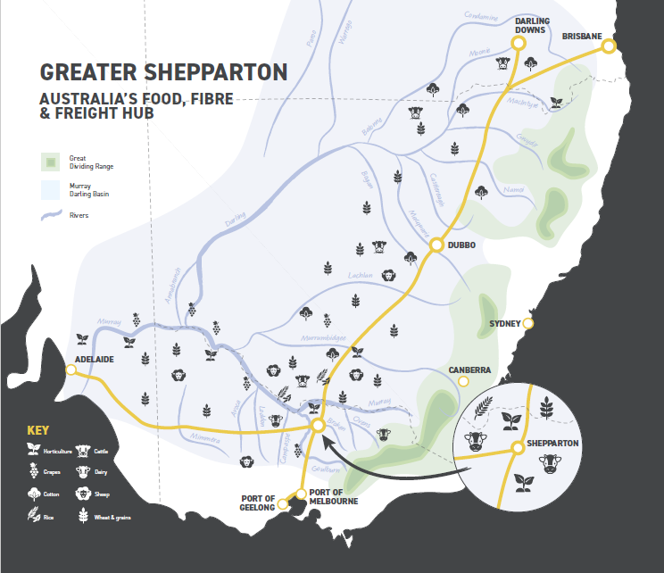

Response to discussion paper

Migration has and remains vital to the growth and success of our region and industry.
Greater Shepparton businesses are recruiting more than 250 professionals and key workers each year from overseas and outside the region, with monthly recruitment tracking around 20 new arrivals. Since 2021 almost 700 professionals with no prior connection have relocated to the region to take up roles with more than 100 local businesses - every sector of activity from lawyers and care workers to food technicians, health specialists and all forms of engineering. Greater Shepparton’s professional migration is remarkable given Greater Shepparton’s total population growth is around 1000 residents per annum.

Unlike the peer cities of Ballarat, Geelong, Bendigo, Wodonga and Latrobe, Greater Shepparton has a very limited university offering. Students cannot undertake degrees in allied health, engineering or logistics while living in Greater Shepparton. As a result, Greater Shepparton is even more reliant on relocating trained and qualified professionals.

Australia’s migration settings must be internationally competitive.
The Migration Settings review acknowledges the complexity and challenges imbedded in national migration and visa settings. Alongside reviewing their mechanics and effectiveness, Australia and especially regional Australia’s reliance on international skills and workforce means we must continuously demonstrate our commitment to migration in words and action – from our international marketing to our processing times.

- It is vital Australia maintains a positive, welcoming ‘posture’ while undertaking necessary reviews and improvements, and in policing the compliance of employers.

- Australia must benchmark its performance against competitors. There are numerous reports from employers that indicate Australia’s processing times are significantly longer than for other ‘competitor’ nations such as Canada.

Questions 6. Noting the limitations of visa settings, what factors encourage more migrants to choose to settle in the regions and improve retention?

Employee retention depends on ‘migrants fully enjoy(ing) the benefits of living and working in (regional) Australia.’

In 2021 C4GS, in partnership with local Greater Shepparton City Council and with grant funding established the Community Connector Program (CCP). As indicated, for 97% of Greater Shepparton’s businesses, recruiting one new staff member represents at least 5% of their entire workforce. Getting the recruitment right is a significant challenge and comes with considerable costs – that are even greater when they include overseas recruitment.

The CCP is available for free to all local businesses. The business refers their new talent to the Program and the CCP works with each professional and their family to support their relocation. Unlike a website or handbook, human contact begins with at least 2 – 3 conversations before the professional relocates. The ongoing connection and support are key to the program’s success. It ensures clients have a friendly, knowledgeable, local contact that is independent of their work and provides a safe place to question and understand social norms and practices, and to navigate new and unfamiliar processes.

The Community Connector is able to provide guidance on housing, schools, childcare, clubs and activities within Greater Shepparton – from assisting with rental application processes (bonds, referees) through to confirming the existence of a ghost hunting club! These interactions help build the relocating professionals’ understanding of their new home town, what to expect when they arrive and helps them ‘hit the ground running’.

The CCP’s contact and support continues for at least 12 months following relocation. This ensures support is available when employees transition out of employer-provided accommodation, partners begin seeking employment, and as children progress through childcare, pre, primary and onto secondary schooling - that are all recognised risk points.

Importantly, the program provides a whole-of-region service which optimises the program’s impact. The whole-of-region model ensures the regular social events and activities continue to broaden relocators’ networks, find friendships outside of their workplace and deepen their connection into the community. It has also enabled more than 100 partners to find employment opportunities.

A further key asset generated by the program is its real time data and insights that are helping Greater Shepparton improve the CCP and the city's ability to attract further professional talent.

Impact and future funding of CCP
Over 3 years the CCP has supported more than 700 professionals, plus their families to relocate to Greater Shepparton to take up roles in more than 100 different businesses. It is estimated the program has delivered more than $50 million of direct economic benefit and a return on investment of more than $300 for every $1 invested.

The Program is now referenced in local business’ international recruitment materials, and in presentations to international careers fairs.

Despite these results, the future of the program is in grave danger because it does not fit neatly into grant funding programs – that experience suggests would prefer to fund a website or booklet rather than the bespoke buddy that is the Community Connector.

A range of alternative funding models have been considered including user pay and subscription services. These models suffered from three key challenges - they require significantly more administration, they do not provide certainty for CCP staff, and most importantly they introduce a significant barrier to business engaging the service in a timely and optimal way.

CCP insights into attraction and retention
The CCP has been pivotal in understanding the needs, expectations and preferences of relocating professionals.
Housing
Housing has proven to be the single biggest challenge to attracting and retaining skilled professionals.
- The CCP spends considerable effort supporting relocators to find accommodation however if the property is not what they expected or preferred it is more than likely the professional will consider relocation to a regional centre where the type of accommodation they want is available.
- There are anecdotal reports of highly sort after professionals declining offers of employment because of the housing typologies available – and not available.
- 94% of relocating professionals want accommodation close to work, in the CBD and generally higher density style apartments and townhouses.
- The CCP confirms there is often more than 60 applicants for a single rental property.
- One- and two-bedroom apartments and townhouses are preferred but make up less than 10% of Greater Shepparton’s housing stock – compared to 25% for regional Victoria.
- This does not suggest relocating professionals do not want a ‘tree change’ – instead they are getting out and enjoying what their new hometown has to offer including its natural environment but without the burden of mowing it!

Local education offering
Compared with other regional centres, Greater Shepparton has a narrow range of post-secondary training opportunities. This means there is little and more often no local opportunity for migrants and their partners to retrain, upskill and maintain the currency of their qualifications and training. This is also frequently raised by relocating professionals wanting to understand the opportunities for their family particularly if they have children in secondary school.

Childcare
Without family networks, relocating professionals need access to childcare and babysitting services to build their careers and participate in their community.

Transport
The lack of frequent, safe and reliable public transport within regional centres and from regional centres is a major obstruction to migrants participating in their community, in education and in work. In Greater Shepparton relocating families will generally require both partners to be able to drive and to have access to two cars. This creates a significant and immediate financial obstacle – particularly for migrants relocating from countries that have restrictions on wealth transfers.

Above all else, the challenges faced by migrants and the reasons that often drive their decision to relocate to a metro centre, are the same challenges faced by the broader regional community –inclusion, and access to education, childcare, housing and transport. Addressing the challenges for migrants benefits the entire community.

Question 7. Do provisional visas successfully encourage large scale retention of migrants in the regions? Is the length of a provisional visa the right length? Should both the regional employer sponsored visa and the regional nominated visa have the same provisional visa arrangements?

Measuring success
Long term retention of professionals in one regional area is not a complete measure of success for skilled regional migration.

The CCP has confirmed that relocating professionals move to progress their career. They expect to relocate for their next role because they know it’s not possible to simply commute to a larger business or hospital in the next suburb.

A more appropriate measure is whether professionals remained for the length of their placement or contract – and whether they left for the right reasons for example to progress their career. The CCP has only been operating for three years however employers are reporting improved retention rates with at least 77% of staff fulfilling their term and more than two-thirds indicating an intention to stay in the region.

8. How can we improve planning for regional migration, especially given the return of migrants to regional Australia post-pandemic? Should there be more flexibility provided to states and territories in planning for regional migration?

Regional migration planning must get ‘under the hood’ of regional economies.
Regional Australia is not homogenous. Greater Shepparton’s economy is dominated by small businesses with 97% of our 6,500 businesses employing less than 20 people. This means recruiting one role represents at least 5% of a business’s entire workforce.

Greater Shepparton’s economy is also diverse – with employment roughly described as ‘20 + 4 tens’ – 20% health, and 10% in each of construction, manufacturing, ag and education. However, within these categories there is considerable diversity, for example manufacturing is dominated by food manufacturing but the second largest export is fabricated metal products.

Continuing automation, technology and innovation are rapidly transforming the skills and needs of industry, for example local fruit packing sheds no longer rely on hundreds of staff on the floor manually sorting fruit. Instead after an initial inspection by one or two staff, the next person to touch the apple or pear is the consumer in the supermarket – but behind the scenes trades and technicians are ensuring the systems run.

The pace of change also means past industry needs and trends cannot be relied on to describe future needs.

The diversity across the economy, within sectors and between businesses means migration planning and programs that attempt to link to specific trades or qualifications must be as agile as the businesses. This knowledge and agility can only come from truly understanding local industry.

Programs that cannot meet this agility threshold test will be redundant before they begin and will forever be playing catch up. C4GS believes agility must be a threshold test for the review and design of migration settings.

Conclusion
Domestic and international migration is essential to meeting the workforce needs of local industry and providing services to the local community.

Greater Shepparton has a long legacy of migration, and this provides a rich understanding of the challenges and the needs of new arrivals.

The Greater Shepparton Community Connector Program has proven effective and valued by clients and businesses – it just needs ongoing co-funding to continue.

The challenges for relocating professionals are shared with the local community – housing, transport, childcare and education opportunities. Solving these challenges benefits everyone.

C4GS extends an open invitation for Department of Home Affairs to work with us to engage with local industry and community to inform the next stages of the review.

