28 June 2024

Submission – Draft Renewable Energy Zone Community Benefits Plan

The Committee for Greater Shepparton (C4GS) welcomes the opportunity to comment on the Draft Renewable Energy Zone Community Benefits Plan.

About C4GS
C4GS is an apolitical, member funded not-for-profit organisation that represents almost 120 businesses, Government agencies and not-for-profit organisations from across the local government areas of Greater Shepparton, Moira and Campaspe.

Our members represent all aspects of our local economy and community. This includes primary production, manufacturing, logistics, warehousing, construction and export supply chains, their support industries as well as regional health, education, waste and service providers. AS one of Australia’s most culturally diverse communities we are proud to count first nations and multicultural businesses and organisations in our membership.

Exciting outlook for an energy dependent region
C4GS welcomes the consultation processes supporting the REZ Community Benefits Plan because they have provided an opportunity to discuss the needs and exciting future for energy-dependent regional centres like Greater Shepparton.

Greater Shepparton’s value adding, manufacturing and processing (VAMP) industries are the engine room of the local economy and represent more than 20% of Victoria’s regional manufacturing. The sector includes world leading companies and iconic brands like SPC, Bega, Unilever, Continental, Noumi, Milk Lab, Campbell’s Soups, Pental, White King, Huggies, Furphy, Flavorite, Saputo, and Kagome. These businesses dominate Australian supermarket staples and therefore efforts to provide secure, affordable energy benefits the wallets of consumers across the nation.

Historically our VAMP sector has relied on local primary production, but today they draw inputs from across Victoria, NSW and South Australia and from right across the Murray Darling Basin. In addition, they have also relied on gas and electricity generated outside the region but today our region is identified as an ideal location for multiple forms of renewable energy generation, storage and use.

The REZ consultation has arrived on the back of considerable local member discussion and exploration of our energy generation, storage and distribution opportunities. This has included hosting multi-day tours by Powercor to inform its Reset, CSIRO engagements with business to replace current gas needs with thermal processing heat alternatives, multiple investigations of Greater Shepparton’s bioenergy potential that makes use of Greater Shepparton’s year-round large volumes of food manufacturing waste and waste water, and ongoing conversations to explore the regulatory limitations for industry ‘micro grids’ or local sharing of our significant local residential solar generation.

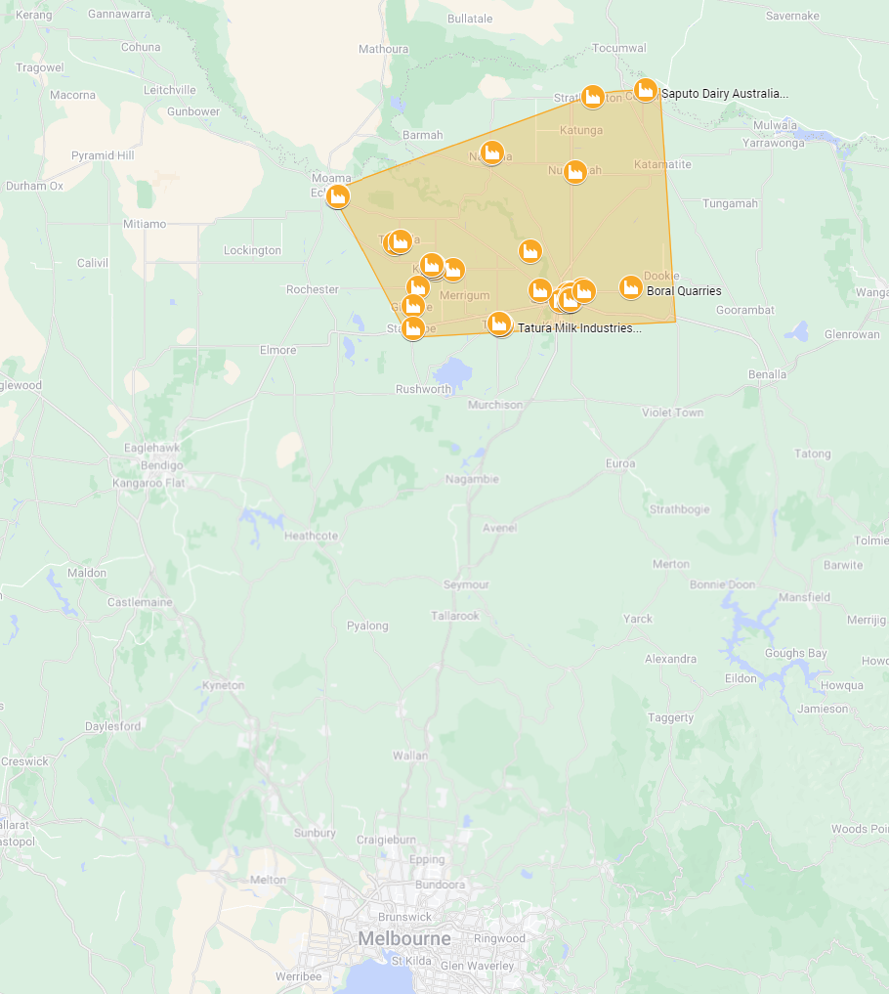 | 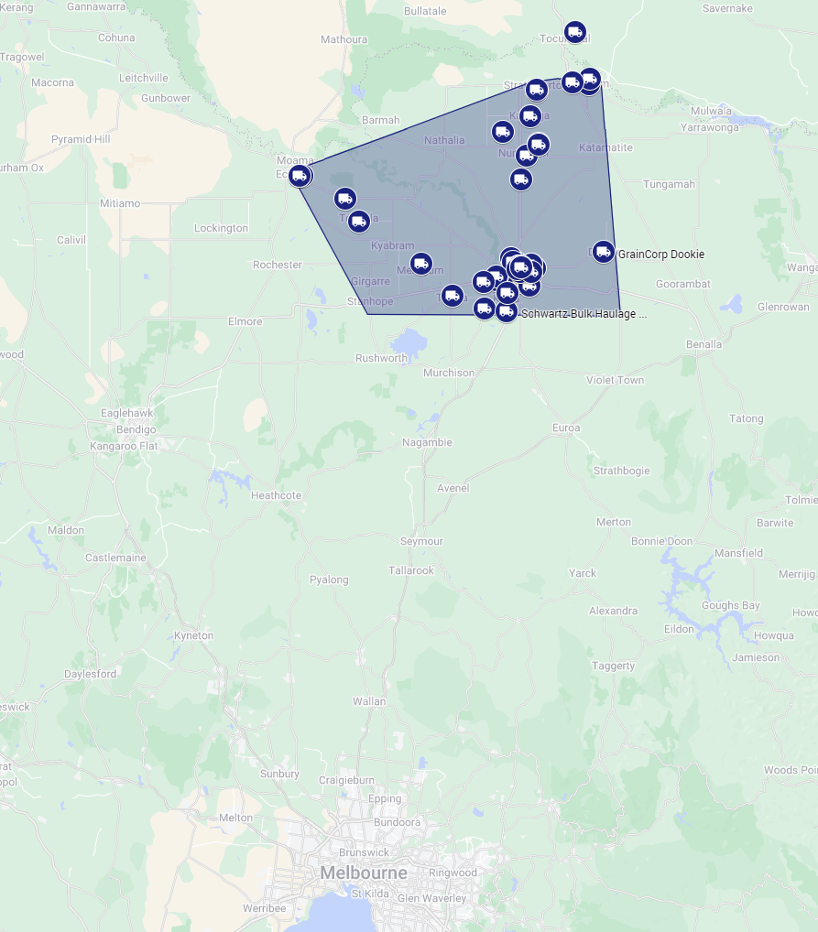
Concentration of value adding, manufacturing and processing sites | Concentration of freight and logistics business

At the same time, local manufacturers continue to report alarming levels of supply disruption. Processors have reported more than weekly supply ‘micro-flicks’ with each flick representing at least $500,000 of lost production for a single site.

REZ Community Benefits Plan consultation
C4GS is of the view a properly framed and strategic community benefits plan has the potential to target investment into energy projects that will unlock the full potential of the region, its communities, industry and education sectors.

At the time of preparing this submission, C4GS is also participating in Victorian Government consultation processes to determine the future impact of the Murray Darling Basin plan, Plan Vic and the update of the Victorian Freight Plan.

C4GS’s footprint is where these processes intersect in ways that could be chaotic or could present an extraordinary alignment of benefits and transition options for individuals and local communities.

C4GS recommends
- The REZ community Benefits Plan recognise the intersection of multiple transformational processes occurring simultaneously in the C4GS footprint, and proactively seek to align these processes to optimise the outcomes and streamline the processes for participants.

Community benefits - Landholders
C4GS recommends
- Landholder benefits must have regard for water owners (entitlement holders) and the water system managers (Goulburn Murray Water). The benefits framework must include the flexibility and exceptional circumstances provisions to ensure no negative impact on remaining water system users and system managers as a result of ownership or land and/or water use changes. This could be achieved by expanding the definition of significantly impacted neighbors but will require further location-based modelling to understand and quantify the financial and operational impact.

- Landowner and community benefits must be framed so they do not disqualify beneficiaries from receiving or participating in other compensation or adjustment schemes that may arise from for example the next stages of the Murray Darling Basin plan.

Community benefits – regional communities
As outlined above, C4GS has initiated a range of programs and connections to support members understand and plan their energy transition. Through these processes we have identified opportunities for collective investment by co-located industry, or by industry and residents, however our region has lacked the resources to undertake detailed feasibility and planning. As a result, initiatives that have progressed have been a result of individual resident or business investment, and the greater potential opportunity has been lost.

C4GS recommends
- REZ Community Energy Funds have scope to fund feasibility studies that may have multiple investor participants and/or multiple beneficiaries. This should include co-funding of feasibility studies for example supporting a business or community group to contribute to the investigation of a shared opportunity where the balance of the project may be considered to be council core business, an extension of a project where construction has already started, or typically funded by other state commonwealth or local government sources.

- While C4GS supports the broad objectives of the eligibility criteria, the challenge will lie in prioritising investment opportunities. For this reason, local governance and well-defined prioritisation and assessment criteria will be key to the credibility and performance of the fund.

- C4GS welcomes Community reference groups but cautions the reliance on Regional Partnerships for decision making in the C4GS footprint. The Goulburn Regional Partnership runs from the Mitchell LGA to Moira LGA (Mitchell to the Murray River). The northern LGAs of Greater Shepparton and Moira sit within the Goulburn Murray Irrigation District. Their gravitational pull is east west not north-south. The Partnerships model would impose an artificial boundary that separates Echuca and the western half of the VAMP precinct from the east and in doing so may compromise the precinct’s ability to optimise outcomes by working together to develop local energy generation, storage, distribution and transmission.

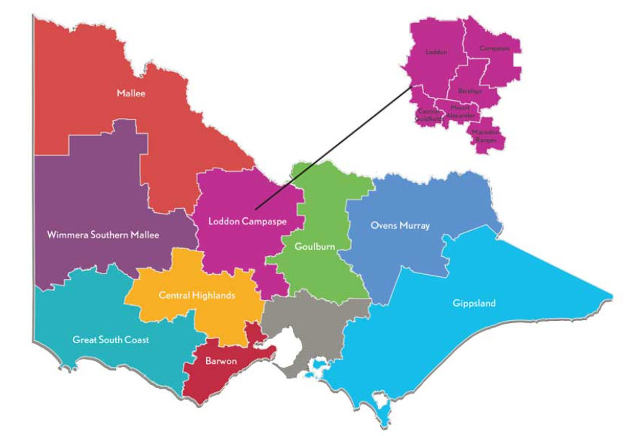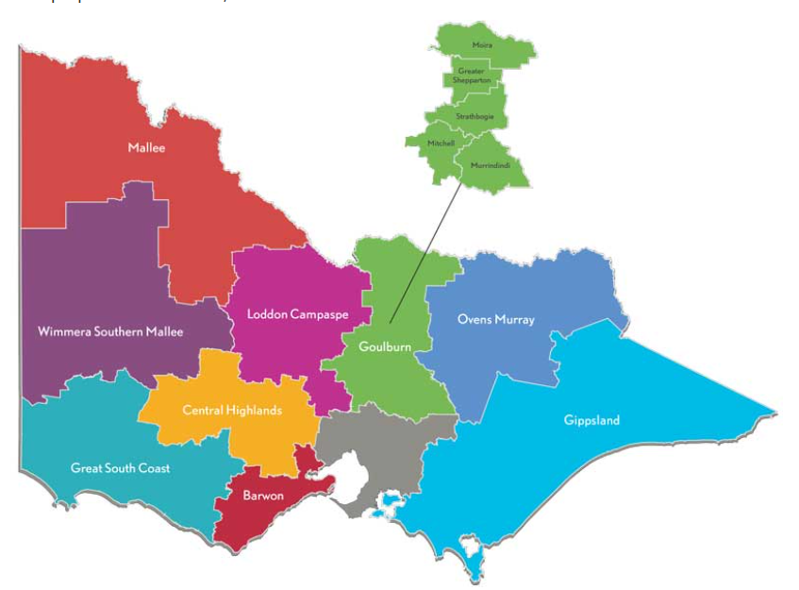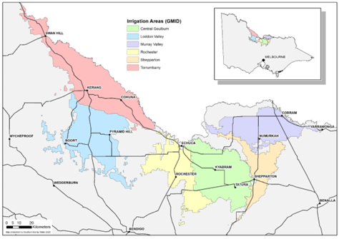

Greater Shepparton has established the Greater Shepparton Foundation, Committee for Greater Shepparton and a number of similar entities that exist to support and enable the region’s prosperity for all.

- C4GS would like to see the commercial acumen, community relevance and long-term commitment imbedded in these organisations engaged in the decision making. These entities are also well placed to be trusted, agile, responsive and collaborative in determining investment opportunities.

Community Benefits – traditional owners
C4GS values its continuing working relationship with its member organisations from the first nations community. C4GS does not presume to speak on their behalf, however we would encourage VicGrid to engage with and support the aspirations and possibilities that are detailed in the Goulburn Murray Regional Prosperity Plan. This provides a pathway for the Yorta Yorta community to achieve greater economic participation and prosperity.

Further matters

Future Land use
C4GS is very aware that our region has some of the most productive and high quality soils in Australia, however within the GMID this land is productive because we are able to bring water to the land – productivity hinges on the combination of affordable water and land - not land on its own. For this reason, we encourage the alignment of the next steps of the Murray Darling Basin with this engagement process.

Freight emissions
Greater Shepparton is home to 25% of Victoria’s registered heavy vehicles. The region has a mix of freight activity from the frequent ‘round trip – return to base’ daily milk collection, horticultural to fresh markets and residential waste collection, to long haul activity across the state and the nation. Greater Shepparton relies on road freight because rail requires multiple handling of delicate product and cannot provide the speed, and cold-chain continuity that is required by our region’s fresh and FMCG product.

The Federal Government is currently developing a Transport and Infrastructure Net Zero Roadmap and Action Plan in consultation with industry to support reducing transport emissions The Victorian Government is also undertaking a review of the Victorian Freight Plan and it also includes discussion about freight emissions and net zero targets.

C4GS recommends the Community Benefits investment provides scope for exploration of and investment in energy intensive industries like freight – recognising our region’s dependence on road freight and the opportunities for R&D, new skills and the new infrastructure and vehicles required to achieve lower and net-zero targets.

Future Engagement processes
C4GS welcomes the Victorian Government commitment to ongoing engagement with impacted communities.

In our experience our members are extremely well networked within their local communities and industries, have the confidence and influence to shape on the ground conversations, and their cross-industry representation is invaluable to understanding challenges and designing solutions that work.

It is our view that working with our membership may assist in better understanding and aligning the options for individuals, communities and the region that may not exist within the scope of energy-only discussions.

Managing consultation fatigue and aligning opportunities
At the time of writing this submission, C4GS (on behalf of and in partnership with members) is responding to a range of government consultations:
- Planning our basin future together (Murray Darling Basin)
- PlanVic – reimagining the future of our cities, suburbs, towns and regions
- Victorian Freight Plan - update
- Apprenticeships incentives review (Federal)
- Review of Regional Migration settings (Federal)
- Transport and Infrastructure Net Zero Roadmap and Action Plan (Federal)

We endeavour to keep our members informed, provide meaningful opportunities to feed their insights and ideas into the consultation processes, and manage the consultation demands on members across the region.

Many of these consultation programs will inform decisions that involve significant public funding and planning for major public infrastructure. Ideally there will be opportunity to optimise the combination of plans and investments – and minimise opportunities lost through suboptimal coordination, communication – and consultation fatigue.

- C4GS recommends and extends an open invite for VicGrid and the Victorian Government to work with C4GS to facilitate a program of engagement with our membership and specific sub-sets of members alongside the engagement with local communities.

Conclusion
C4GS members include the full sweep of economic and social interests in our region. From global leading brands and businesses to local first nations and multicultural associations. Our members are united by the commitment to the continuing prosperity of our region and the opportunity for all to be a part of this success.

The Community Benefits plan provides an opportunity for our region to unlock its full potential through targeted investments in energy generation, storage, distribution and transmission, and also in projects that drive long term positive outcomes.

We look forward to the opportunity to discuss our submission in further detail.

Yours sincerely

Linda Nieuwenhuizen
CEO
Committee for Greater Shepparton

